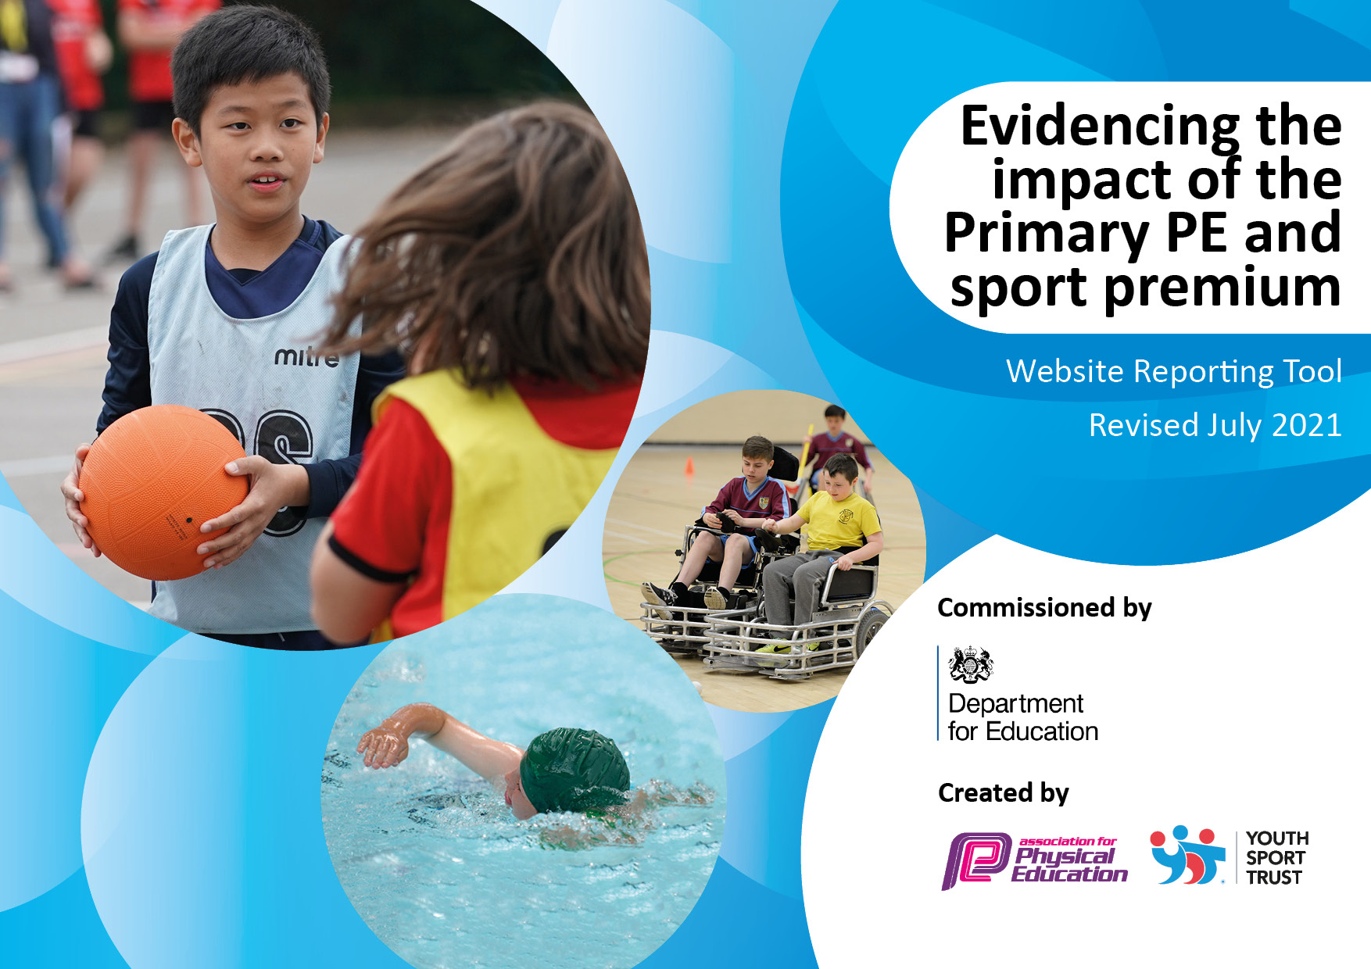
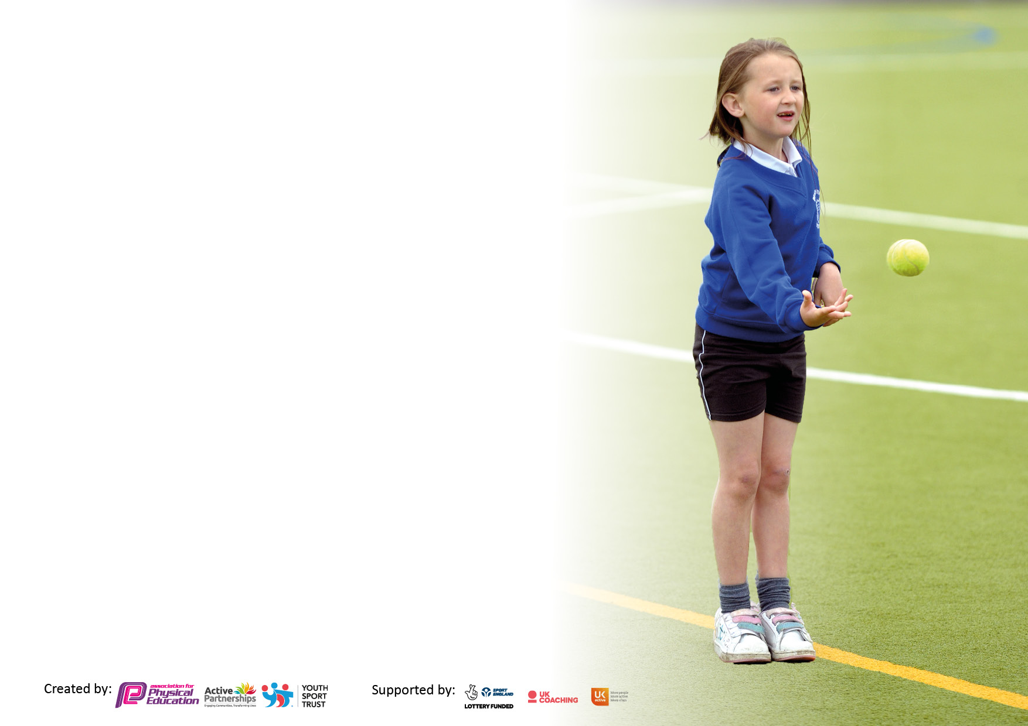

It is important that your grant is used effectively and based on school need. The Education Inspection Framework makes clear there will be a focus on ‘whether leaders and those responsible for governors all understand their respective roles and perform these in a way that enhances the effectiveness of the school’.

Under the Quality of Education Ofsted inspectors consider:
Intent - Curriculum design, coverage and appropriateness
Implementation - Curriculum delivery, Teaching (pedagogy) and Assessment
Impact - Attainment and progress

To assist schools with common transferable language this template has been developed to utilise the same three headings which should make your plans easily transferable between working documents.

Schools must use the funding to make additional and sustainable improvements to the quality of Physical Education, School Sport and Physical Activity (PESSPA) they offer. This means that you should use the Primary PE and sport premium to:

- Develop or add to the PESSPA activities that your school already offer
- Build capacity and capability within the school to ensure that improvements made now will benefit pupils joining the school in future years
- The Primary PE and sport premium should not be used to fund capital spend projects; the school’s budget should fund these.

Pleasevisitgov.ukfortherevisedDfEguidanceincludingthe5keyindicatorsacrosswhichschoolsshoulddemonstrate animprovement.Thisdocumentwillhelpyoutoreviewyourprovisionandtoreportyourspend.DfEencouragesschools to use this template as an effective way of meeting the reporting requirements of the Primary PE and sport premium.

We recommend you start by reflecting on the impact of current provision and reviewing the previous spend.

Schools are required to publish details of how they spend this funding, including any under-spend from 2019/2020, as well as on the impact it has on pupils’ PE and sport participation and attainment. All funding must be spent by 31st July 2022.

We recommend regularly updating the table and publishing it on your website throughout the year. This evidences your ongoing self-evaluation of how you are using the funding to secure maximum, sustainable impact. Final copy must be posted on your website by the end of the academic year and no later than the 31st July 2021. To see an example of how to complete the table please click HERE.

Details with regard to funding
Please complete the table below.

Total amount carried over from 2019/20 | £4700
Total amount allocated for 2021/22 | £24300 - £8195 spent
How much (if any) do you intend to carry over from this total fund into 2022/23? | £16105
Total amount allocated for 2022/23 | £19600
Total amount of funding for 2022/23. To be spent and reported on by 31st July 2023. | £35705
Swimming Data
Please report on your Swimming Data below.

Meeting national curriculum requirements for swimming and water safety.

N.B. Complete this section to your best ability. For example you might have practised safe self-rescue techniques on dry land which you can then transfer to the pool when school swimming restarts.
Due to exceptional circumstances priority should be given to ensuring that pupils can perform safe self rescue even if they do not fully meet the first two requirements of the NC programme of study
What percentage of your current Year 6 cohort swim competently, confidently and proficiently over a distance of at least 25 metres?  N.B. Even though your pupils may swim in another year please report on their attainment on leaving primary school at the end of the summer term 2020.  Please see note above | 80%
What percentage of your current Year 6 cohort use a range of strokes effectively [for example, front crawl, backstroke and breaststroke]?  Please see note above | 71%
What percentage of your current Year 6 cohort perform safe self-rescue in different water-based situations? | 100%
Schools can choose to use the Primary PE and sport premium to provide additional provision for swimming but this must be for activity over and above the national curriculum requirements. Have you used it in this way? | Not this year – the time available at the pool wasn’t suitable. As previously, we plan to fund top up lessons for Year 6 in the next academic year.

Action Plan and Budget Tracking
Capture your intended annual spend against the 5 key indicators. Clarify the success criteria and evidence of impact that you intend to measure to evaluate for pupils today and for the future.

Academic Year: 2022/23 | Total fund allocated: | Date Updated: 30/10/22
Key indicator 1: The engagement of all pupils in regular physical activity – Chief Medical Officers guidelines recommend that primary school pupils undertake at least 30 minutes of physical activity a day in school |  |  |  | Percentage of total allocation:
 |  |  |  | 50%
Intent | Implementation |  | Impact
Your school focus should be clear what you want the pupils to know and be able to do and about  what they need to learn and to  consolidate through practice: | Make sure your actions to achieve are linked to your intentions: | Funding allocated: | Evidence of impact: what do pupils now know and what can they now do? What has changed?: | Sustainability and suggested next steps:
Headline Intended Impact on Pupils – All pupils will be active on average 60 minutes a day, 7 days a week.  - Provide a range of activities through further development and implementation of extra-curricular timetable. Increase the number of clubs and activities to increase participation and active minutes.  - Agreed that Energy Clubs for KS1 piloted in Summer of 2023.  - Develop provision for physical activity at lunchtime by; Increasing the amount of active playground resources for activity facilitated by Primary and Secondary Sports Leaders. | - Continue to liaise with families and students through student voice and baseline survey voice to find out the clubs and activities that pupils want to be attending.  -CTA to organise survey monkey for parents through KLA.  -Student voice through YST Chateeze resource to simplify student voice, to ensure inclusion and access for as many students as possible. and through in class baseline survey.  -Energy Club offer reflects school context of PE/PA/SS needs based on SG program and targeted PA evidenced from student voice, parent survey and baseline survey.  -Record access through the Complete PE Physical Activity Assessment function.  -Bounce Beyond taster day on delayed from September due to electrical issue in Sports Hall. Re-arranged date TBC.  - Continue to provide high quality extra-curricular clubs that are parent paid and therefore do not require any funding or teacher led and so free to attend.  -CTA liaise with CGE and THY to ensure Energy Club Booklet (Active Clubs) is sent separately to the Primary Twilight Club offer. Ensure parents understand that there is no limit on Energy Club sign up.  -Liaise with Primary Sports Partnership, The Saffrons, University of Brighton, Tennis in The Park and Eastbourne Rugby Club to further develop the existing opportunities as well as developing new community club links.  - Where required, quality assured CPD to upskill primary staff leading or wishing to lead, clubs  - Continue to foster community links with other primary schools, local clubs and coaches to provide additional/combined opportunities.  -Liaise with Primary Sports Partnership, The Saffrons, University of Brighton, Tennis in The Park and Eastbourne Rugby Club to further develop the existing opportunities as well as developing new community club links  - Investigate new activities with the aim of attracting those who have not yet attended extra-curricular – Bounce Beyond, Ultimate frisbee, Lacrosse, Quidditch, Golf – or to enable students to access to the curriculum.  -Inclusion resources from YST, access to research on best practice and most up to date initiatives.  - PP funding and free places given to support families who need extra - help accessing these clubs.  -Families eligible for PP funding continue to have pre-release access to the Energy Club offer.  -CTA liaise with THY. Ensure EAL families have access to Energy Club Offer by using office translate function on the Energy Club Booklet.  - Sports leaders trained.  -Dodgeball Leaders course booked for Autumn Term 22. Re-arranged to (secondary) 16th and (primary) 23rd November. Funding sought from SGO.  - Create activity schedule (informed through student voice) so Sports leaders can maximise physical activity at lunchtime and be closely monitored by Duty team.  - Equipment and resources to be bought for facilitation of activity with Sports leaders as well as independent active play.  - Utilise leadership ideas from Complete PE.  - Investigate further NGO leaders courses and funding from the SGO.  - Continue land based self-rescue training in Year 5&6, expand this with Year 6 students leading sessions to Year 3&4.  - Look at swimming qualification for additional staff-to further reduce cost in future in the case of the PSSP being discontinued.  - Investigate the ‘top up’ sessions being an extra-curricular club to ease pressure on staffing in Summer 1/2. | £TBC Complete PE annual membership.  £1500 other new equipment TBC  Basketball Posts and protectors. £17,569.70  YST Chateeze Resource  £100  Primary Leaders Package  £99 | In 2022-2023 40% of students in Years 3-6 had attended Energy Club /active club either before or after school. Year 3 had a slightly reduced offer, the figure for those attending clubs in Years 4 to 6 was 60%.  - Overview of extra-curricular activities that the children participated in: Gymnastics, Dance, Netball, Dodgeball, football, boxing, Athletics, Cricket, rounders.  - Extra-curricular registers of attendance.  - By July 2023, more students had attended an extra-curricular active/sports clubs.  Evidenced through:  - Overview of extra-curricular activities that the children participate in.  - Extra-curricular registers of attendance.  - Student Voice survey.  By July 2023 with the addition of 9 basketball posts, more children were choosing to be physically active across a typical week at lunchtime on the back of new equipment available to break.  Considering the lunchtime and extra-curricular additions, on top of activity outside of school:  By July 2023, we are going to challenge more pupils to achieve an average of 60 minutes a day 7 days a week. | To provide increased access for more students, Energy club start time moved from 7.45am to 8am, to run until 8.30am. Discuss and seek outside providers for before and after school clubs to increase opportunities for EYFS/KS1&2 energy clubs.  Further work to develop sports leader role for UKS2 and KS3 student involvement in facilitating activity at breaks and leading a program of Level 1 intra school events.  Purchase further breaktime equipment along with outside storage.  Complete baseline physical activity survey using Microsoft forms.  Bi Termly meeting with primary practitioners who teach PE to support and highlight good practice, monitor level of challenge and introduce physical activity assessment function.  Specialists provide a program of in house CPD.  Spring Energy club offer allocated to focus on alternative activities.  Revisit student voice and baseline data to continue to work on plans and intentions that were not realised in this academic year.
Key indicator 2: The profile of PESSPA being raised across the school as a tool for whole school improvement |  |  |  | Percentage of total allocation:
 |  |  |  | 6%
Intent | Implementation |  | Impact
Your school focus should be clear what you want the pupils to know and be able to do and about  what they need to learn and to  consolidate through practice: | Make sure your actions to achieve are linked to your intentions: | Funding allocated: | Evidence of impact: what do pupils now know and what can they now do? What has changed?: | Sustainability and suggested next steps:
Headline Intended Impact on Pupils – All pupils’ personal development will be developed and celebrated.  In addition, supporting the target for all pupils to be active on average 60 minutes a day, 7 days a week  - Celebrate and assess the whole child through Physical Education ensuring strong personal development. Continue celebrations by including PE and School sport in a Celebration assembly every term to ensure the whole school is aware of the importance of PE and Sport and to encourage all pupils to aspire to being involved.  - Promote physical activity outside of school and celebrate with the community. | Challenge the personal development of all pupils by:  - Celebrate and assess Physical Education in line with Complete PE success outcomes that challenge Physical, Cognitive. Social and Emotional outcomes. Record both formative and summative assessment using the Complete PE assessment functions for PE/PA/SS & Swimming.  -Training for primary staff on using the Physical Education tracking functionality on the Complete PE platform so that all units can be assessed, and the Standards achieved in PE NC are improved with at least 95% achieving end of KS attainment target (ARE) in all lessons, not just those taught by the Subject Lead.  - Continue to add photo evidence to Year Group display boards.  -2 additional notice boards to be ordered as one taken for primary safeguarding display and one for Art.  -Develop library of clips for each age group.  - Introduce ‘Champions’ book for all celebrations and comments to be recorded. (Before school, break, lunch, PE, after school all to be included.) With ‘success’ seen to be physical, cognitive, social and emotional.  -x2 additional Champions books to be ordered. Did not arrive or were lost when waiting collection from the Photocopy room.  - Achievements in PE and School sport to be celebrated in assembly (ASPIRE, house and individual challenges, festival reports, match results + notable achievements in lessons from the Champions Book.) Different classes to showcase PE learning -for example either live or recorded Dance/Gymnastics/Invasion game performance.  -CTA to liaise with class teachers and CGE re timing of these. CTA to pass on information to class teachers/CGE where she can’t be present. Champions book and displays used as evidence.  - Sporting stars display – Students to write up match reports from fixtures and competitions.  - Develop team support role.  - Organise for pupils with sporting stories/successes from outside of school to bring in photos/writing for the display. Included here anything that’s a new physical activity  - Use Chateeze resource referenced in Key Indicator 1 to assess and evidence impact of recognition on notice boards/in assemblies/champions book.  - Research development of school mascot to bring PESSPA to life for students, particularly in EYFS/KS1 and for students with SEND. Seen during YST practitioner support webinar with a primary school in Kent. | £1600  Complete PE membership referenced in Key indicator 1.  Champions Books x2  Notice Boards for each year group PE activities x 1  A PESSPA Notice Board x 1  Youth Sports Trust Membership £555 | - See PE attainment data (whole child) in Key Indicator 3.  - Through the addition of the ‘champions’ book, we predict that by July 2023, more pupils will have been celebrated in our assemblies. This will be a celebration of the whole child – physical, cognitive, social or emotional learning  - The notice boards/HT newsletter are full of information about activities/matches/clubs/results and students are keen to get involved.  WIDER IMPACT AS A RESULT OF ABOVE  - 100% of Pupils feel proud to be involved in assembles/photos on notice boards etc. which is impacting on confidence and self-esteem – see pupil voice  - Standards achieved in PE NC are improving with at least 95% achieving end of KS attainment target (ARE).  - Year 6 – 98%  - Year 5 – 93%  - Year 4 – 98%  - Year 3 – 98%  - Year 2 – 93%  - Year 1 – 95%  - EYFS – 97% | Revisit student voice and baseline data to continue to work on plans and intentions that were not realised in this academic year.

Key indicator 3: Increased confidence, knowledge and skills of all staff in teaching PE and sport |  |  |  | Percentage of total allocation:
 |  |  |  | 3%
Intent | Implementation |  | Impact
Your school focus should be clear | Make sure your actions to | Funding | Evidence of impact: what do | Sustainability and suggested
what you want the pupils to know | achieve are linked to your | allocated: | pupils now know and what | next steps:
and be able to do and about | intentions: |  | can they now do? What has
what they need to learn and to |  |  | changed?:
consolidate through practice:
Headline Intended Impact on Pupils – All pupils’ will receive 2 hours high quality physical education every week.  100% of pupils will be developed in their physical, cognitive, social and emotional learning.  Supporting the target for all pupils to be active on average 60 minutes a day, 7 days a week.  - To ensure all children are participating in two hours a week of high-quality PE the Quality of teaching and learning in Physical Education, develop a program of CPD for all class teachers.  - Additional courses/CPD programs for other areas of the curriculum and NQT support.  - Utilise Complete PE platform resources and curriculum Subject Lead support to ensure high quality delivery and consistency of the PE provision. | - Ensure Complete PE annual membership is paid to ensure quality and quantity of resources for lessons allows for High Quality Physical Education and pupil attainment.  - Quality of teaching and learning in Physical Education will be developed through program of staff CPD for all class teachers based on confidence survey and lesson observation. Support from Subject leader included.  -Complete Pe Dance specialist booked to lead exemplar lessons on the 19th and 20th October with an online follow up session for non-specialist primary staff (to be arranged with CGE.) Includes access to additional resources to use in lessons and action plans for those staff who accessed the specialist led lessons.  - Subject Lead requested time during Autumn INSET to lead gymnastics focus CPD using Complete PE webinar as best practice resource. Not possible due to relaunch of Whole school vision, mission and values. To be followed up by CTA.  -Training for primary staff in the Complete PE platform assessment functionality.  -Learning walks facilitated by primary staff recording one session a term. Subject Lead to use these to assess areas of development, CPD next steps, feedback on good practice and create action plans. | Complete PE Membership cost as referenced in Key Indicator 1.  Complete PE Dance Specialist led exemplar lessons, online training and resources.  £1000 | As a result of a bespoke CPD program - Complete PE support/courses, in house 1-1 CPD, staff insets, courses, interactive SOW clips and updating equipment we expect to see significant impact:  Staff Confidence in September 2021 shows that 15% of teachers feel confident in teaching all areas of PE.  We predict that by September 2023, most staff feel confident in teaching Dance and Gymnastics.  Autumn 1 Lesson observation data showed that % of lessons were good or better. Team teaching throughout the Summer Term with the aim that by September 2023 we predict that all teachers will have been trained in at least two areas of the curriculum and that more lessons in these areas being delivered will be good or better.  Student voice data in Autumn 1 2022 shows that 80% of students enjoy PE. By July 2023, we predict that this will increase.  Pupil attainment data in July 2022  By July 2022, we predict that 95% of FS, 95% of KS1 and 95% of KS2 will achieve ARE.  WIDER IMPACT AS A RESULT OF ABOVE  - Standards achieved in PE (whole child development) are improving with a minimum 93% achieving end of KS attainment target (ARE) in every year group.  - Staff voice evidences the impact of High-Quality PE on the pupil's attainment in class. | Time limits external cpd – use of in-house expertise to develop non specialist staff confidence.  Revisit staff and student voice and baseline data to continue to work on plans and intentions that were not realised in this academic year.  Ensure that Subject lead has time to support primary teachers with learning walks and student voice.  Bi Termly meeting with primary practitioners who teach PE to support and highlight good practice, monitor level of challenge and introduce physical activity and physical education assessment function.
Key indicator 4: Broader experience of a range of sports and activities offered to all pupils |  |  |  | Percentage of total allocation:
 |  |  |  | 13%
Intent | Implementation |  | Impact
Your school focus should be clear | Make sure your actions to | Funding | Evidence of impact: what do | Sustainability and suggested
what you want the pupils to know | achieve are linked to your | allocated: | pupils now know and what | next steps:
and be able to do and about | intentions: |  | can they now do? What has
what they need to learn and to |  |  | changed?:
consolidate through practice:
Headline Intended Impact on Pupils – All pupils’ will be exposed to new areas of activity.  Supporting the target for all pupils to be active on average 60 minutes a day, 7 days a week  Continue to offer a wider range of activities both within and outside the curriculum to get more pupils involved.  Focus particularly on those pupils who do not take up additional PE and Sport opportunities and girls.  Additional achievements: | Develop program of events to promote opportunities to experience activities not included on the curriculum and/or to foster physical activity.  Bounce Beyond Taster Rearranged for Autumn 2 – December.  . Follow up with staff training and purchase of class set of rebound trampolines.  - Additional training for Sunset/Sunrise (SEND) staff and equipment allocated to Jump Ahead.  - Include Bounce Beyond as an extra-curricular Energy Club activity.  -Investigate mobile climbing wall experience for KS2 students in Spring 1&2. With a view to create an on-site climbing wall with 22/23 PSSP funds.  - Arrange Skipping Day provider to visit in Summer 1&2.  - Follow up with Sports Leaders training and purchase of Year group resources for students to use independently at break and to lead activities for younger year groups.  -develop Tennis in The Park free coaching offer to combine staff CPD with student experience and engagement. | Bounce Beyond Taster Day  Rebound Trampolines x 40  £4854 | - We predict that 100% of pupils will enjoy the climbing wall experience taster sessions and this will increase the number of pupils seeking active lifestyles outside of school. See Complete PE Physical Activity Assessment data and student voice.  - We predict that 100% of pupils will enjoy Bounce Beyond Taster day and this will increase the number of pupils seeking active lifestyles outside of school. See Complete PE Physical Activity Assessment data and student voice.  - We predict that 100% of pupils will enjoy Skipping Day sessions and this will increase the number of pupils seeking active lifestyles outside of school. See Complete PE Physical Activity Assessment data and student voice.  - Teaching staff feel more confident leading new activities and become involved in extra- curricular activities.  WIDER IMPACT AS A RESULT OF ABOVE  - Increased percentage of students say they enjoy PE and Sport and want to get involved in more activities both in school and in the community. | Revisit student voice and baseline data to continue to work on plans and intentions that were not realised in this academic year.

Key indicator 5: Increased participation in competitive sport |  |  |  | Percentage of total allocation:
 |  |  |  | 0%
Intent | Implementation |  | Impact
Your school focus should be clear | Make sure your actions to | Funding | Evidence of impact: what do | Sustainability and suggested
what you want the pupils to know | achieve are linked to your | allocated: | pupils now know and what | next steps:
and be able to do and about | intentions: |  | can they now do? What has
what they need to learn and to |  |  | changed?:
consolidate through practice:
Headline Intended Impact on Pupils – Increase the number of pupils participating in an increased range of competitive opportunities. Supporting the target for all pupils to be active on average 60 minutes a day, 7 days a week and supporting personal development of all pupils.  Ensure provision of intra and inter school festivals and competitions covers level 1 and level 2 and is inclusive and accessible to all. | - Use Complete PE platform functionality to record and track engagement with intra. inter Level 1 and level 2 comps.  - Competition will be imbedded as a normal element of learning at level 1 stage through continued access to activity competitions in class/lesson time. Supported through Complete PE SOW  -A2 - Three-week rotation of activity in Year 4-6. Weeks 5 and 6 are allocated for a choice of competitive and festival opportunities with the dual focus of ASPIRE values and physical skill.  - Further develop the timetable of Intra events for KS1 and 2 to engage and inspire all.  - Funding though SGO for Secondary Sports Leaders as well as commitment of PE Dept to funding Leadership opportunities alongside volunteering roles required by DofE/6th Form courses will facilitate school games events.  - Train and engage secondary and primary leaders in assisting and leading these events. See Dodgeball Leaders Course from Key Indicator 1.  -Develop inclusive Intra tennis activities as a lead up into selection of the teams for 2023 Sussex Tennis Championships. Link with Tennis in the Park and combine with Tennis Leaders program from LTA.  -Develop inclusive Intra cricket activities as a lead up into selection of the teams for 2023 Sussex Cricket Foundation events. Combine with Chance to Shine Leadership program.  - Organise and host inter school and festival program of events for the local primary sports partnership.  - Engage and train leaders from UK2 and secondary/6th Form to assist with the planning and leading of these events.  -Football: organising and hosting two U11 - 7 a side Primary Football Leagues (mixed and girls) at The Saffrons from Tuesday 1st Nov to Tuesday 13th November.  -Cross Country: in partnership with Ratton School, hosting and organising the Eastbourne Area Primary Cross Country Qualifier at Eastbourne Rugby Club on Thursday the 10th November.  -Football: Week Commencing 8th March Girls Football Festivals.  -Netball: Spring 1 KS2 Bee Netball Festivals. Spring 2 – organise and host the Eastbourne cluster qualifying tournament, organise and host the South Downs Area School Games Qualifying tournament the week after.  -Summer 1 KS1 ABC UK Athletics Festivals.  - Apply for school games mark  -Autumn 2 meeting with Liz Price SGO to discuss new School Games framework.  - Primary Sports Day  Develop new structure, inclusive with appropriate challenge  -Hosted and run by student leadership – Sports Champs, Celebration Champs – other invited students. | £ | 2021/22, 40% of children KS2 competed in 2 level 1 competitions.  By July 2023 the number of level 1 competitions accessed will have been increased. All KS2 student will have access to at least three level 1 competitions.  Competitions to have a dual focus on success via demonstration of Aspire school values as well as physical development. Combines with Key Indicator 2.  Evidence - Complete PE Physical Activity Assessment data and student voice.  By July 2023 the percentage of KS1 and 2 students involved in inter school festivals and competitions will have been increased due to increased opportunities offered by organising and hosting events for the Primary School Partnership. | Interschool events - Hosted and led a series of events for the primary school partnership:  Cross Country  Football  Netball  Intra school events -  Football  Netball  Hockey  Quadkids  Indoor Pentathlon  Revisit student voice and baseline data to continue to work on plans and intentions that were not realised in this academic year.  Begin planning for Primary Sports Days in Spring 1

Signed off by
Head Teacher:
Date:
Subject Leader: | Chloe Taylor
Date: | 24/07/23
Governor:
Date:

